**Experiment - 1.6(a)**

**Student Name: Milan Sharma UID: 23MAI10003**

**Branch: ME – CSE - AIML Section/Group: MAI – 1 (A)**

**Semester: 1st Date of Performance: 06 Sep 2023**

**Subject Name: Python Programming Subject Code: 23 CSH 623**

1. **Aim of the Experiment :**

Write a python program to demonstrate the use of distinct string functions.

1. **Objective of the Experiment :**

To demonstrate the use of distinct string functions.

1. **Algorithm/ Steps for Experiment**

1.        Create and initialize a string

2.        Call a string function to perform an operation on strings

3.        Display the string

1. **Code for Experiment :**

txt = "hello, and welcome to my world."

x = txt.capitalize()

print (x)

txt1 = "Hello, And Welcome To My World!"

x1 = txt.casefold()

print(x1)

txt2 = "I love apples, apples are my favorite fruit"

x2 = txt2.count("apple")

print(x2)

txt3 = "Hello, welcome to my world."

x3 = txt3.find("welcome")

print(x3)

txt4 = "Hello My Name Is PETER"

x4 = txt4.swapcase()

print(x4)

1. **Result/Output :**

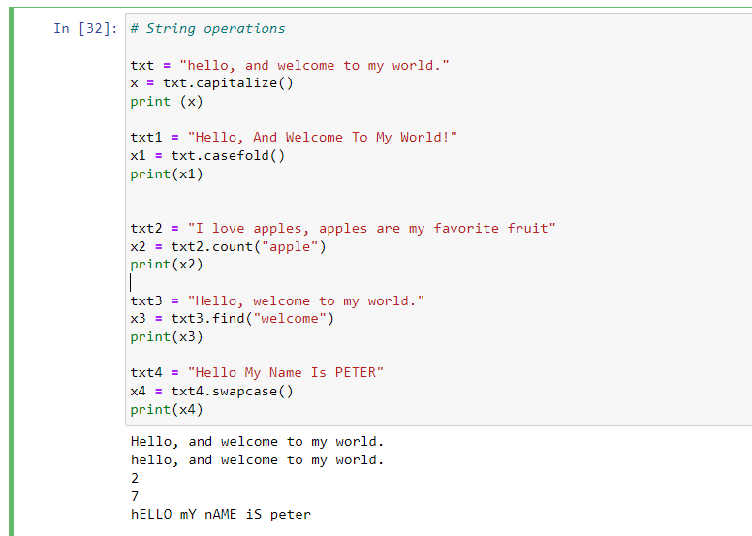

**Learning outcomes (What I have learnt):**

1. Learnt different operations performed on strings.

**Evaluation Grid (To be created as per the SOP and Assessment guidelines by the faculty):**

|  |  |  |  |
| --- | --- | --- | --- |
| **Sr. No.** | **Parameters** | **Maximum Marks** | **Marks Obtained** |
| **1.** | **Student Performance**  **(Conduct of experiment)**  **Objectives/Outcomes.** | 12 |  |
| **2.** | **Viva Voce** | 10 |  |
| **3.** | **Submission of Work Sheet**  **(Record)** | 8 |  |